Artificial Intelligence  
Lab Exercise 10  
Implementation of NLP

short line

Ashwin Prakash  
RA1911026010048

**Aim:**

To implement a NLP algorithm

**Problem Statement:**

To implement a NLP algorithm on a real-life dataset

**Algorithm:**

1. Install the necessary packages.
2. Fetch the movie review dataset from NLTK library corpus
3. Construct a list of documents labelled with appropriate categories.
4. Define a feature extractor for documents making the classifier pay attention to certain aspects of data.
5. Train the model with Naïve Bayes Classifier to predict sentiment of new movie reviews
6. Test the model against the validation data and compare the results.

**Program:**

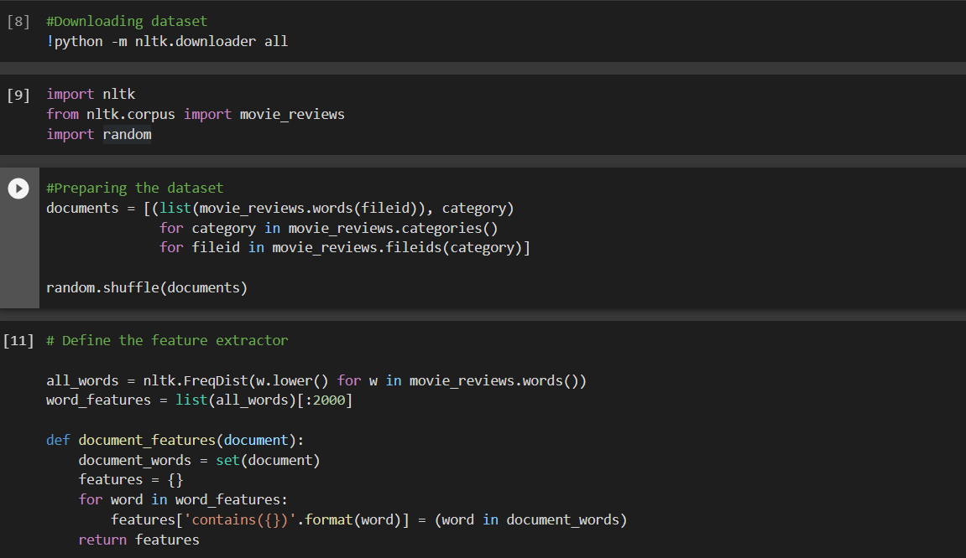

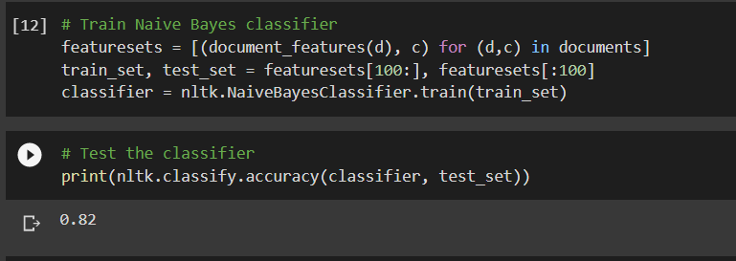

**Output:**

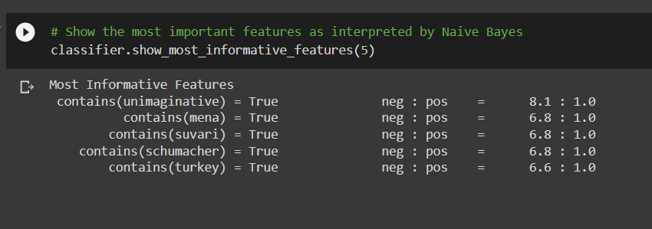

**Observations:**

1. From the informative features, Unimaginative is 8 times more likely to be negative than positive.
2. The rest of the features, although offers importance , won’t affect the sentimentality of the statement and this might be due to dependence between various predictors
3. We used Naïve Bayes considering the fact of the events being independent but in real life use cases, it is almost impossible to get predictors which are entirely independent of each other.

**Inference:**

The NLP Algorithm has been successfully implemented on a real-life use case.

**Result:**

Implementation of NLP problem is implemented successfully.